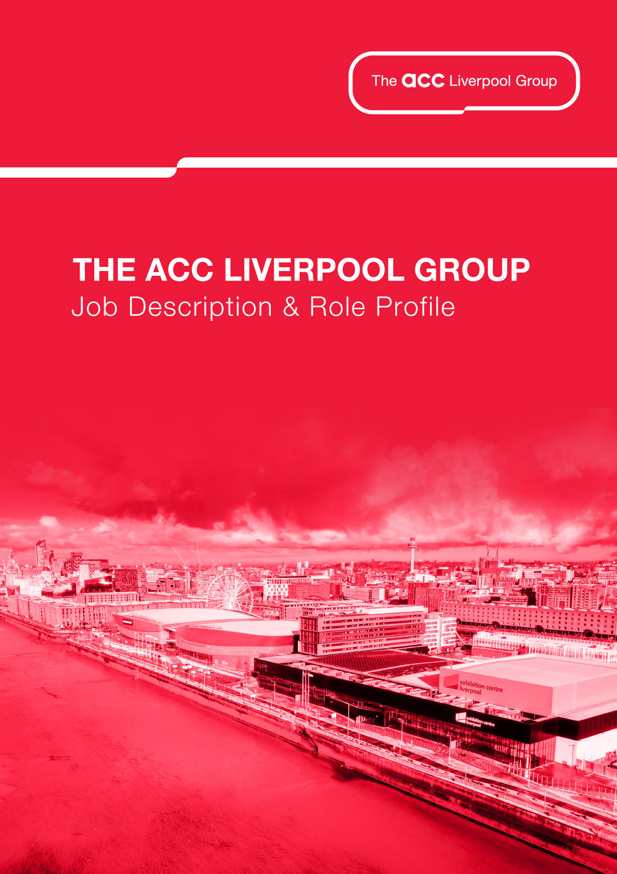

Operations and FM
Security Officer

REPORTS TO: Security Supervisor

DIRECT REPORTS: NA

JOB PURPOSE

To contribute to the safety and security of The ACC Liverpool Group premises, staff, guests, and visitors.

To provide all visitors to The ACC Liverpool Group with a warm and friendly welcome, ensuring that a high level of customer service is always provided.

MAIN DUTIES AND RESPONSIBILITIES

- Understand and actively contribute to the delivery of The ACC Liverpool Groups Security Strategy and Venue Risk Assessment to ensure requirements are met.
- Maintain the security control room, systems and its access to ensure compliance with The ACC Liverpool Groups CCTV Policy.
- Maintain access to ACC Liverpool premises and restricting access to ensure there are no unauthorised personnel.
- Maintain a detailed understanding of The ACC Liverpool Groups visitor management system and support procedures to ensure they are adhered to.
- Conduct person, property, and vehicle searches to meet The ACC Liverpool Groups policies and procedures, or as requested by Operations management.
- Provide a high visibility presence in around the ACC Liverpool Groups premises, to reassure guests and visitors and act as deterrent any hostile activity.

- Maintain the integrity, accuracy and confidentiality of all information gained to ensure it is secure at all times by strict compliance with The ACC Liverpool Groups CCTV policy.
- Act as first respondent to any security, first aid or emergency situation that arises on The ACC Liverpool Group premises.
- Record any incidents on ACC Liverpool Groups premises and the surrounding areas and escalate to security management or emergency services where appropriate.
- To complete a scheduled PPM programme on certain safety systems across the campus which includes regular fire alarm testing, evac chair, disabled alarms to name a few.
- Communicate and liaise effectively both verbally and in writing with all visitors to The ACC Liverpool Group to ensure excellent standards of customer service.

GENERAL

- To contribute to the success of our One Team culture to deliver our aims and objectives, maintaining a flexible and positive attitude.
- To adhere to The ACC Liverpool Group’s Health and Safety policies and procedures and to observe a duty of care to all visitors, staff and contractors to ACC Liverpool.
- To undertake any other duty commensurate with this post as determined by your manager.
- This job description is not intended to be either prescriptive or exhaustive; it is issued as a framework to outline the main areas of responsibility at the time of writing.
- It is inevitable over time that the emphasis of this job will change, therefore this information will be periodically reviewed, revised and updated involving the post holder.

ROLE PROFILE

ATTRIBUTES | DESCRIPTION | ESSENTIAL/ DESIRABLE | HOW MEASURED
TRAINING &  QUALIFICATIONS | SIA Door Supervisors licence - Essential  SIA CCTV operator’s licence - Desirable |  | I A
EXPERIENCE | Demonstrable experience of crowd management - Desirable  Demonstrable experience of queue management - Desirable  Significant experience of control room operations – Essential  Demonstrable experience of working in a security role in the events industry - Desirable |  | I A
SKILLS & KNOWLEDGE | Basic customer service skills - Essential  Awareness of evacuation procedures - Essential  Basic IT skills – Essential  Basic knowledge of Action Counter Terrorism (ACT) guidance - Desirable |  | I A
KEY ATTRIBUTES | Pragmatic, resilience, influencing, confidence, conflict resolution - Essential |  | I A
Key for How Measured:

I - Interview P - Presentation A - Application E - Exercise T - Test AC - Assessment Centre CS - Case Study

Signed by Employee:

Date: ____________________________

Signed by Line Manager _________________________

Date ____________________________

